1. 
2. **Agenda**:
   1. <https://github.com/in28minutes/MockitoTutorialForBeginners/blob/master/Step03.md>
   2. 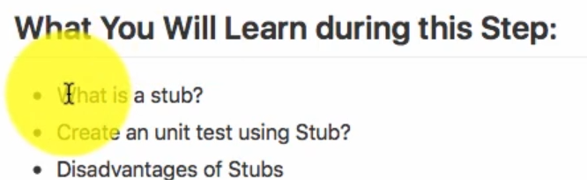
3. **Stub**: Stub is nothing but a **sample implementation** to return sample data. Such as in our case for **TodoService.java** which is an interface.
4. 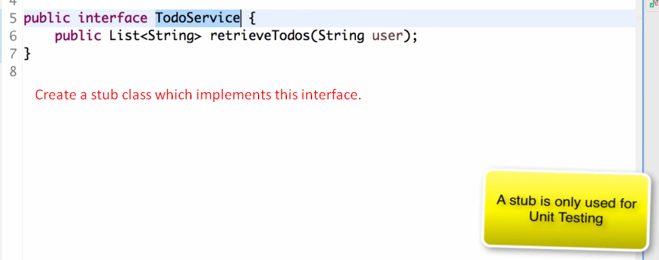
5. 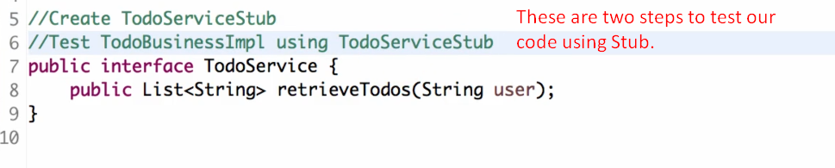
6. 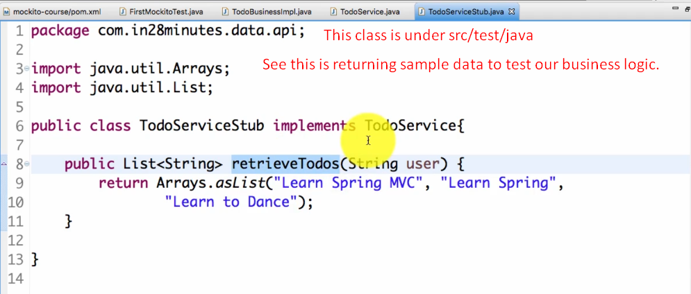
7. 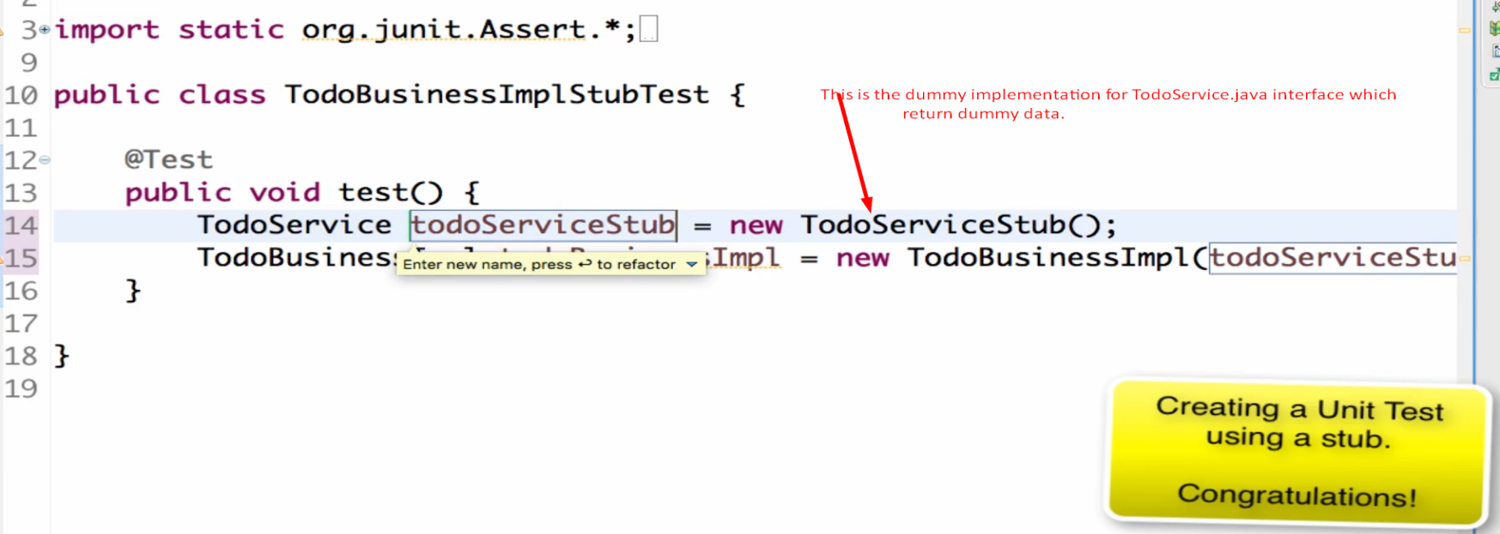
8. 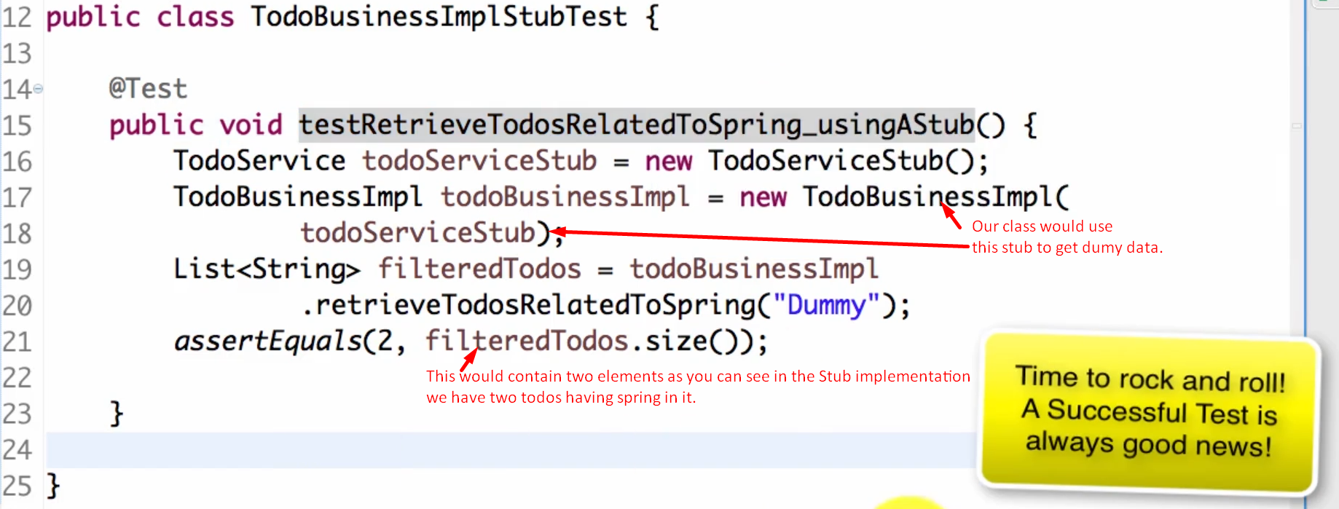
9. 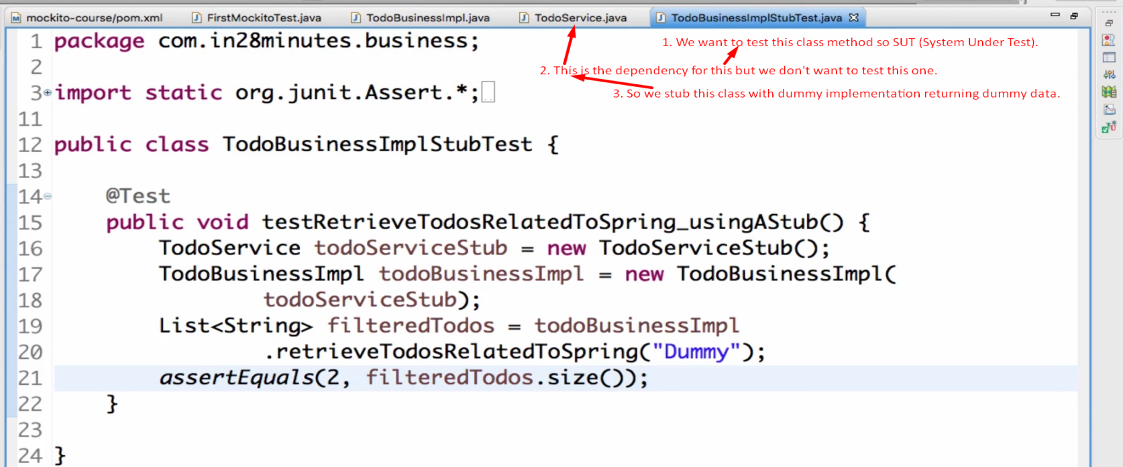
10. 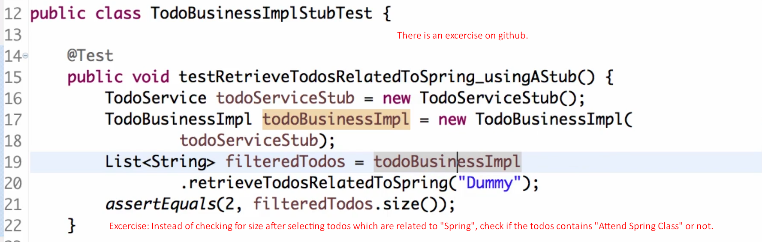  
    But we’re not focusing on the exercise for stubs but on what is advantages and dis-advantages of stubs.

Let’s talk about disadvantages of stub

1. 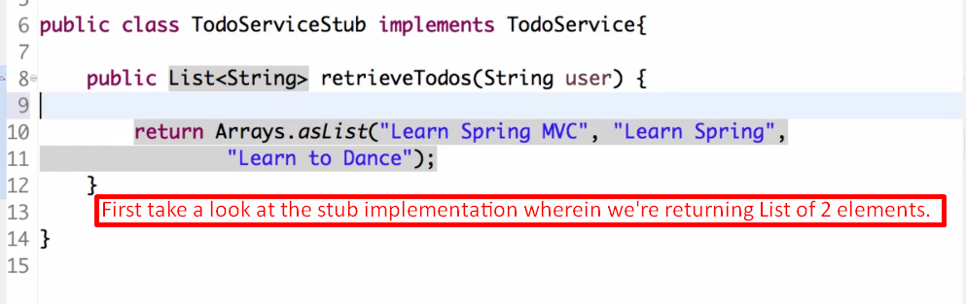
2. 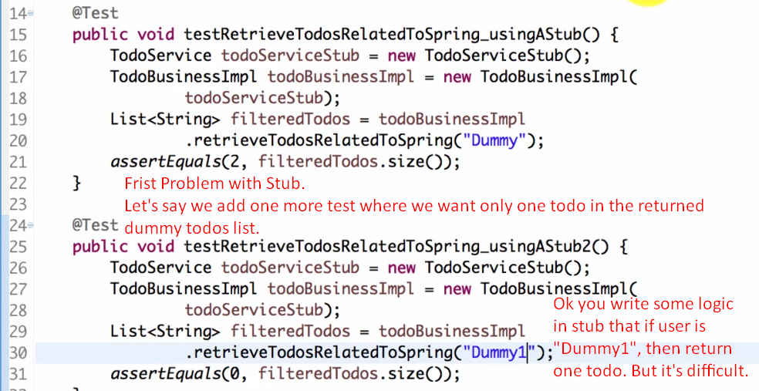
3. 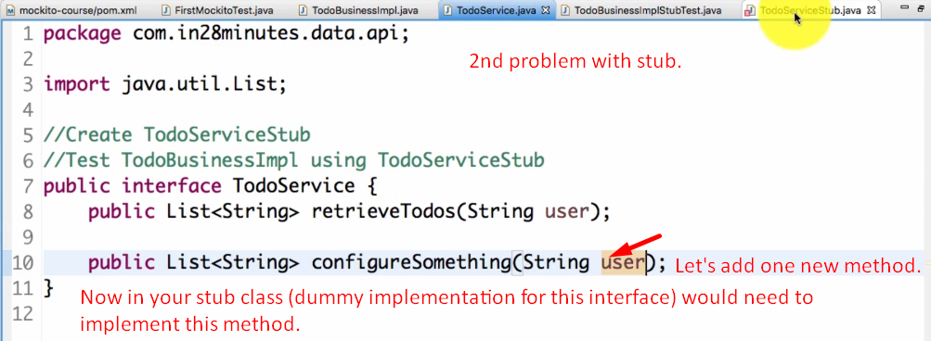
4. 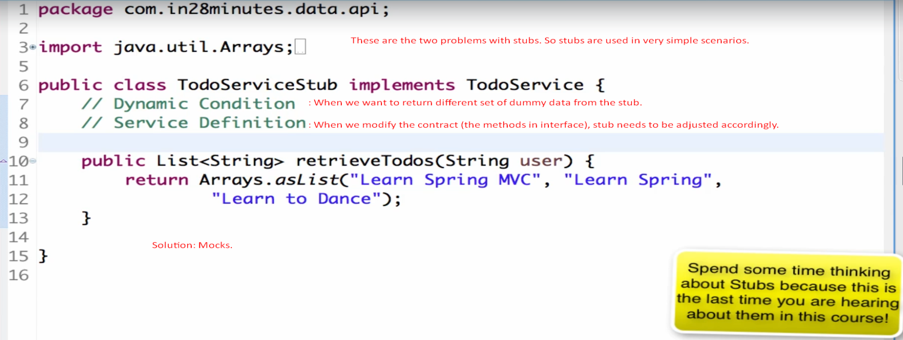
5. Brief discussion about **the problems in case of Stub**
   1. If we want to return **different set of data** for different calls, we need to change the code in stub method.
   2. If we **add one more method** to the actual interface for which stub class was created, we need to adjust the stub class itself.